|  |  |
| --- | --- |
| Date | 30 October 2022 |
| Team ID | PNT2022TMID45285 |
| Project Name | IoT Based Gadget child safety monitoring and notification |
| Name | S.Muhsina Barveen |

ASSIGNMENT-4

Write code and connection in wowki for ultrasonic sensor.When ever distance is less than 100 cm send the alert to IBM cloud and display in device recent event.

#define ECHO_PIN 2

#define TRIG_PIN 3

void setup() {

Serial.begin(115200);

pinMode(LED_BUILTIN, OUTPUT);

pinMode(TRIG_PIN, OUTPUT);

pinMode(ECHO_PIN, INPUT);

}

float readDistanceCM() {

digitalWrite(TRIG_PIN, LOW);

delayMicroseconds(2);

digitalWrite(TRIG_PIN, HIGH);

delayMicroseconds(10);

digitalWrite(TRIG_PIN, LOW);

int duration = pulseIn(ECHO_PIN, HIGH);

return duration * 0.034 / 2;

}

void loop() {

float distance = readDistanceCM();

bool isNearby = distance < 100;

digitalWrite(LED_BUILTIN, isNearby);

Serial.print("Measured distance: ");

Serial.println(readDistanceCM());

delay(100);

}

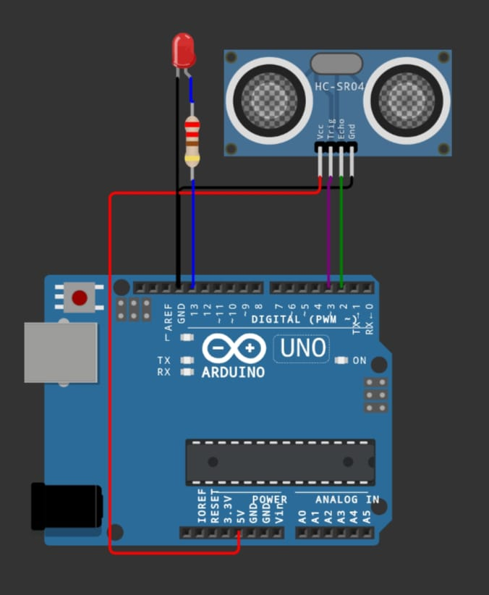

LINK:https://wokwi.com/projects/290056311044833800